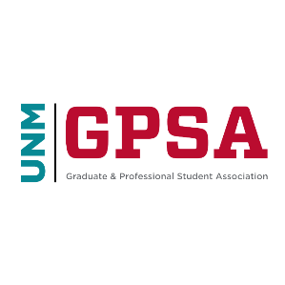
UNIVERSITY OF NEW MEXICO’s GRADUATE & PROFESSIONAL STUDENT ASSOCIATION,
LEGISLATIVE STEERING COMMITTEE

NOTICE OF LSC MEETING
Wednesday, September 29, 2021 at 3:00 pm
Virtual Meeting: ZOOM ID: 936 7683 5445, Password: 233 147

The University of New Mexico’s Graduate and Professional Student Association (GPSA) Legislative Steering Committee (LSC) will hold its first meeting of 2021-2022 school year on Wednesday, September 29, 2021 at 3:00pm via ZOOM. This will be a regular meeting.

