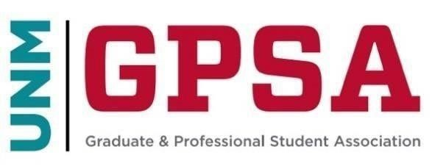
General Council Meeting
May 4th, 2024
https://unm.zoom.us/j/5642195662
- Call to Order
  - Confirmation of Quorum
  - Adoption of Agenda
  - Indigenous People’s Land and Territory Acknowledgment
- Opening Business
  - Approval of the Minutes
  - Media, Gallery, and Public Comments (Both related to the agenda, and not related to the agenda)
- Guest Speakers
- Officer Reports
  - President Lauriano
  - Council Chair Ronquillo
- Committee Reports
- Discussion
- Action Items 1.
  - BILL TO AMEND-006 ARTICLE IV COUNCIL STEPENDS
  - BILL TO AMEND-007 GPSA BUDGET AND ACTUAL DISCLOSURE
  - BILL TO AMEND-008
- Upcoming Meetings
- Adjourn

