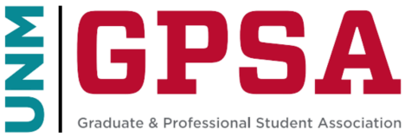
GPSA President’s Cabinet Meeting
Link: https://unm.zoom.us/j/96637954426 | Wednesday, October 22, 2025 | 4:00pm – 5:00pm MT
Location: GPSA Office Room and Zoom
AGENDA

I. Check-In (5 min)
- Purpose: Grounding and quick personal/professional updates.
- Discussion: Brief introductions and check-in round.

Guiding Questions:
- What have you been working on? Any challenges, needs? How can we support you?

II. Updates & Reports (~4 - 5 min each)
- Council Chair’s Update
- President’s Update
- Chief of Staff’s Update
- Office Manager’s Update
- Grants Director’s Update
- Public Relations & Development Director’s Update
- Finance Committee Update (Chair and Vice Chair)
- Board of Directors, Committees & Elections Update
- Legislative Steering Committee (LSC) Update
- Political Director’s Update
- Attorney General’s Update
- Chief Justice’s Update
- North-Campus Liaison’s Update
- Sustainability Director's Update

V. Other Information / Announcements (3 min)
• Open floor for any final updates.

VI. Wrap-Up & Next Steps (2 min)
- Summarize action items and responsibilities.
- Confirm next meeting date.

