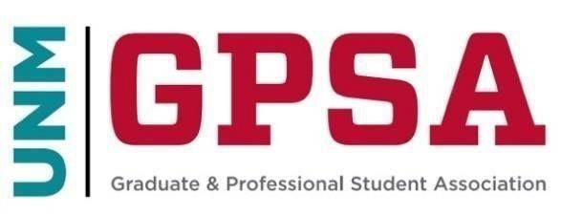
Legislative Steering Committee Meeting
March 17, 2026, 4:00 pm
Mirage – Thunderbird Room
https://unm.zoom.us/j/95323254742

- Roll Call
Present:
Marisa Page
Saheed Oyeniran
Mason Leachman
David Lonergan
Absent:
Will Bieker
Aidan Dunne
Kodiak Ly
- Opening Business — motion Mason Leachman, second Marisa Page, approved unanimously
  - Approval of the Agenda
  - Approval of previous minutes — in questions Saheed pointed out misspelling of last name, motion to correct Saheed’s last name by Mason Leachman, second by Marisa Page, — motion to approve by Saheed Oyeniran, second by Marisa Page, approved as written with correct spelling.
  - Media/Gallery/Public Comment
    - Travis Broadhurst
- Discussion on bills — open and consider bills jointly: motion by Marisa Page, second by Saheed Oyeniran, approved unanimously.
  - DRAFT Bill S-2026-003
  - DRAFT Bill S-2026-004
    - Question:
      - Marisa Page on Bill S-2026-003:
        - Can Jacob explain more?
        - Why didn’t NALSA sign on?
    - Discussion:
      - Mason Leachman on Bill S-2026-003:
        - Comment to note the law school’s SBA (Student Bar Association) has not signed onto the letter.
    - Both bills pass unanimously.
- Guest Speakers
  - None
- Discussion on bill proposed by guests
  - None
- Announcements
  - Longer April meeting for bylaws revisions (breakfast, lunch, and potentially dinner provided)
- Upcoming meeting
  - EITHER April 14, 2026, at 4:00 PM in Mirage/Thunderbird
  - OR April 11, 2026, at 9:00 AM SUB (room TBD)
    - Decided on April 11, 2026, at 9:00 AM in the SUB
- Adjourn: 4:29 p.m.

