
LEGISLATIVE STEERING COMMITTEE

BILL F 2025-001 FALL 2025 SESSION
Constitution

Legislative Action:

Introduced by: Council Chair Jacob Griego, LSC Chair David Lonergan

1st Reading: LSC Chair Referred To: LSC
2nd Reading: LSC 11/12/25 Committee Action: Passed
3rd Reading: Council Meeting 11/22/25 Council Action: Introduced
4th Reading: 12/6/2025 Council Action: Passed

Executive Action:
- Approved  Vetoed

___January 16, 2025______
GPSA President Date

Unsigned by the President on this _16th_ day of _January_ 2025. Bill automatically becomes law.

Legislative Response:
Veto override vote taken: _________________ Council Action: ___________________

Summary of key changes/points:
- The Constitution of the Graduate and Professional Student Association of the University of New Mexico
- *Removal of the former GPSA logo*
- THE CONSTITUTION OF THE GRADUATE AND PROFESSIONAL STUDENT ASSOCIATION OF THE UNIVERSITY OF NEW MEXICO
- *Add in below current GPSA logo*
- Found in GPSA Constitution Title Page
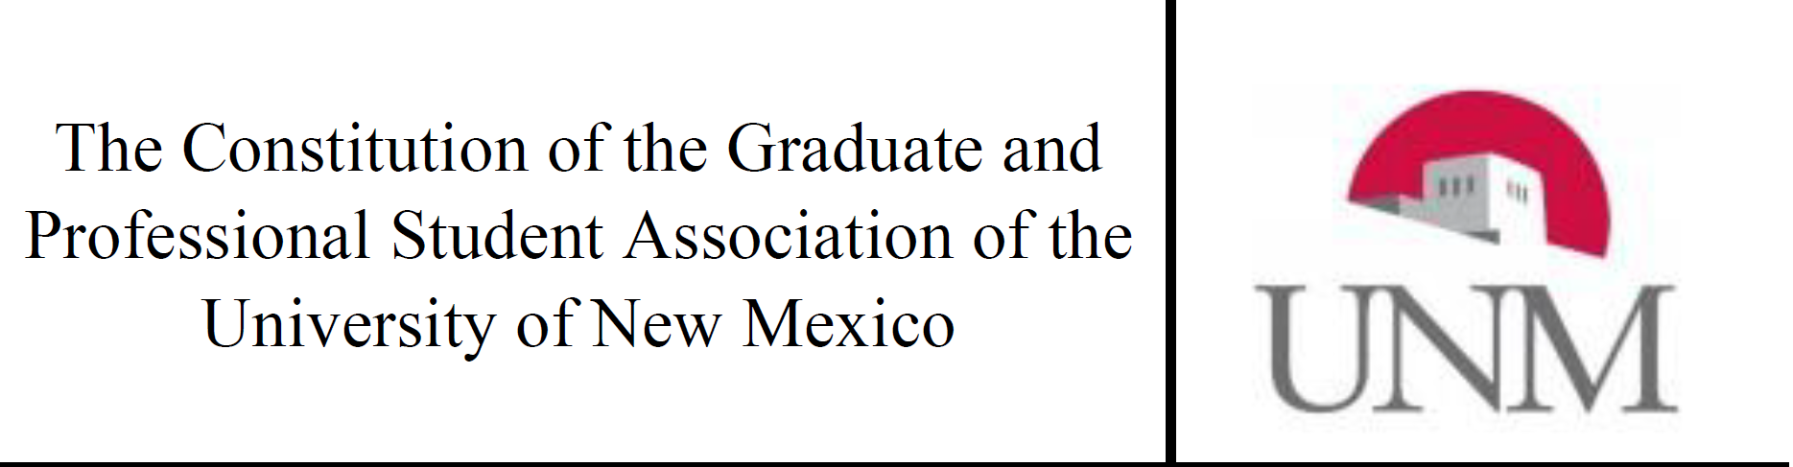
THE CONSTITUTION OF THE GRADUATE AND PROFESSIONAL STUDENT ASSOCIATION OF THE UNIVERISTY OF NEW MEXICO


