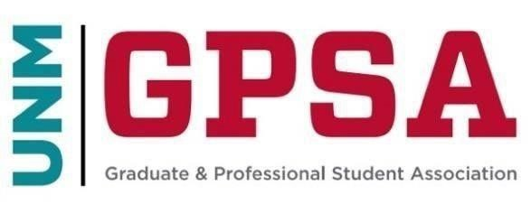
General Council Meeting
March 30th, 2024
Student Union Building Room 1047
https://unm.zoom.us/j/5642195662
- Call to Order
  - Confirmation of Quorum
  - Adoption of Agenda
  - Indigenous People’s Land and Territory Acknowledgment
- Opening Business
  - Approval of the Minutes
  - Media, Gallery, and Public Comments (Both related to the agenda, and not related to the agenda)
- Guest Speakers
  - Lisa Walden- Director of UNM Bookstores
- Officer Reports
  - President Lauriano
  - Council Chair Ronquillo
- Committee Reports
- Discussion
  - GPSA Council Candidate Forums
  - Bill-S24-002
- Action Items
  - Bill-S24-003
  - Bill-S24-004
  - Bill-S24-005
  - Bill-S24-006
  - FY 25 Budget Bill
  - Association of Geology Graduate Students- $654.00
  - Sociology Graduate Student Association- $1,256.00
  - Electrical and Computing Graduate Student Association- $654.00
  - Hindu YUVA- $704.00
  - Nepali Student Association- $2,213.00
  - Islamic Medical Association- $503.00
  - Indian Student Association- $503.00
  - Physics and Astronomy Graduate Student Association- $402.00
  - Graduate and Professional Student Association- $39,371.00
- Upcoming Meetings
  - April 20th at 10am in person and over zoom
- Adjourn

