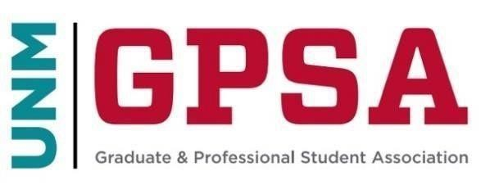
General Council Meeting
April 20th, 2024 https://unm.zoom.us/j/5642195662
- Call to Order
  - Confirmation of Quorum
  - Adoption of the Agenda
  - Indigenous People’s Land and Territory Acknowledgment
- Opening Business
  - Approval of the Minutes
  - Media, Gallery, and Public Comments (Both related and nonrelated to the agenda)
- Guest Speakers
- Officer Reports
  - President Lauriano
  - Council Chair Ronquillo
- Committee Reports
- Action Items
  - Election
- Ian Carrillo
- Ansely Emeanuwa
- Lexi Kenis
- Ashish Joshi
  - Bill-S24-002
  - Association of Women Surgeons- $503.00
  - Association of Latino Professionals For America- $503.00
- Upcoming Meetings
a. May 4th at 10am over zoom and in person
- Adjourn

